# BLUETOOTH BASED HOME AUTOMATION USING ARDUINO UNO

# Guided By: Dr. Jayaseelan D ;

# Presented By : Praveen S, Sabari J, Pavithran A V, Priyakanth K;

**ABSTRACT:**

The home automation is the future and important part of a house. The home automation is highly reliable in system for controlling house electrical appliances. As technologies improves the home automation system are becoming smarter and can regulate certain tasks automatically and autonomously. The home automation systems are cost effective and reduces the consumption of energy of household and cut the cost of electricity bills. In this paper a home automation system is discussed, the system controls the electrical appliance of house by using user interface device and speech recognition technology by using micro-controller device via a Bluetooth module and a mechanical relay acting as a switch for controlling electrical appliances.

**Keywords:** Home automation, Electrical appliances, Speed recognition.

**INTRODUCTION:**

The voice controlled smart home automation system helps to control electrical appliances by using voice commands. The system uses Bluetooth module for transmitting data for controlling functioning of electrical loads. The Bluetooth can receive input signal from any a device which have Bluetooth compatibility such as smartphone. The smart home automation is most beneficial for handicap or aged people. The system solve the problem of switching on/off electrical appliances because when user just have to give voice command to control the appliance or electrical loads. The system is designed in such a way user can control all appliance at once or can control each separately. The system works by interfacing the on/off switches of electrical appliance or loadsby using mechanical relay or solid state replay, after connecting relays in system the electrical switch works as two way switch. The voice command is sent by using a software designed for controlling the system, a built in microphone and voice recognition system implemented in device such as Samsung’s Bixby. A micro-controller (Arduino Uno) is implemented in system, the micro controller receives input signal from user device and sent signal to respective relay for turning on/off electrical appliances connected with system such as bulbs, fan, air conditioner unit etc.

**ARDUINO UNO :**

Arduino Uno is a hardware which have a programmable IC Atmega328P and programmed by using computer software Arduino IDE. The device have multiple input and output pins for controlling multiple unit and sensors, also for receiving input for multiple sensors and different input devices. Arduino UNO is a single board computer. Arduino is an open source physical computing platform based on a simple input/output (I/O) board. The type of the Arduino board used in this paper is ATMega328P Arduino Uno Microcontroller having 2KB static RAM, 32KB flash memory, 8 bit CPU, 6 Analog I/O pins and 14 Digital I/O pins . The language used to program the Arduino microcontroller is C/C++. Programs are created in the Arduino development environment that compiling and linking source code and downloaded to the Arduino board where it start running

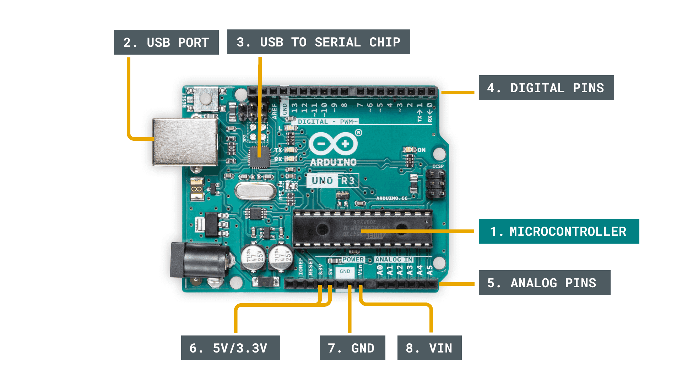

**Figure : Arduino Uno**

**HC-05 Bluetooth Module**

The HC-05 is an easy to connect and easy to used Bluetooth module, which is designed for wireless serial connection. The Bluetooth module can be used as master or slave configuration, making it best solution for wireless connection or communication. This module is version 2.0 Bluetooth communication technology which is great for transferring and receiving data in fast rate.

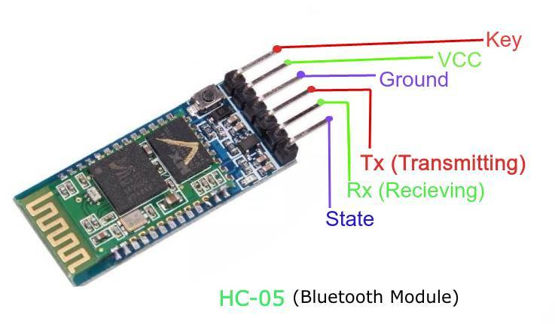

**Figure: Bluetooth Module**

**Mechanical Relay**

The mechanical relay have capability for acting as switch for turning on and off electrical loads. They Woks simply by providing small electrical power in form of electrical signal. This allow high power loads controlled by using small amount of power. The mechanical relay uses electromechanical coil to open and close the circuit. When small amount of current passes through coil it excites the coil and generates magnetic field and either pull the bar or release the bar which is used for opening and closing the circuit, here opening and closing means restricts flow of current and vice versa respectively.

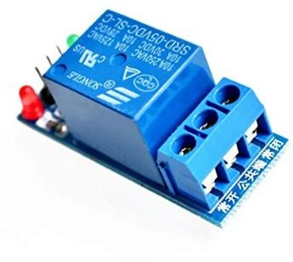

**Figure : Relay**

**PROPOSED MODEL OF PROJECT**

The system is designed by using three main components, first is microcontroller Arduino Uno, second is Bluetooth module HC-05 and third is mechanical relay. Firstly user gives the command to microcontroller by using speech recognition system of smartphone and system software application via Bluetooth module HC-05. The microcontroller acts accordingly to the command give user and control the functionality of mechanical relay.

The Arduino Uno is programmed using Arduino IDE which is software, the user interface application is designed using MIT app inventor platform.

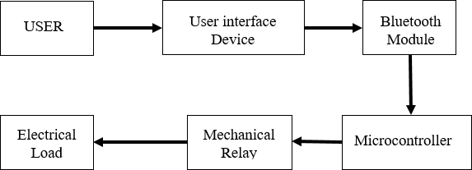

**Figure : Block Diagram**

## CONCLUSION:

The project is designed by keeping in mind needs of all consumers for performing operation of turning on and off electrical appliance by using user interface device by giving voice commands wirelessly. The Bluetooth module can be removed and instead of Bluetooth module high range communication device can be implemented in system for better and reliable use of system.

## REFERENCE

1. A. Paul, M. Panja, M. Bagchi, N. Das, R. M. Mazumder, and S. Ghosh, “Voice recognition based wireless room automation system,” in *2016 International Conference on Intelligent Control, Power and Instrumentation, ICICPI 2016*, 2017.
2. A. Bekkelien, “Bluetooth indoor positioning,” *Master’s thesis, Univ.*

*Geneva*, 2012.

1. T. S. Ng, “Microcontroller,” in *Studies in Systems, Decision and Control*, 2016.
2. E. L. Horsley, M. P. Foster, and D. A. Stone, “State-of-the-art piezoelectric transformer technology,” in *2007 European Conference on Power Electronics and Applications, EPE*, 2007.
3. D. R. Tobergte and S. Curtis, “Arduino Uno,” *J. Chem. Inf. Model.*, 2013.
4. A. Cotta, N. T. Devidas, and V. K. N. Ekoskar, “HC-05 BLUETOOTH MODULE INTERFACED WITH ARDUINO,” *Int. J. Sci. Eng. Technol. Res.*, 2016.
5. M. Spencer *et al.*, “Demonstration of integrated micro-electro- mechanical relay circuits for VLSI applications,” in *IEEE Journal of Solid-State Circuits*, 2011.